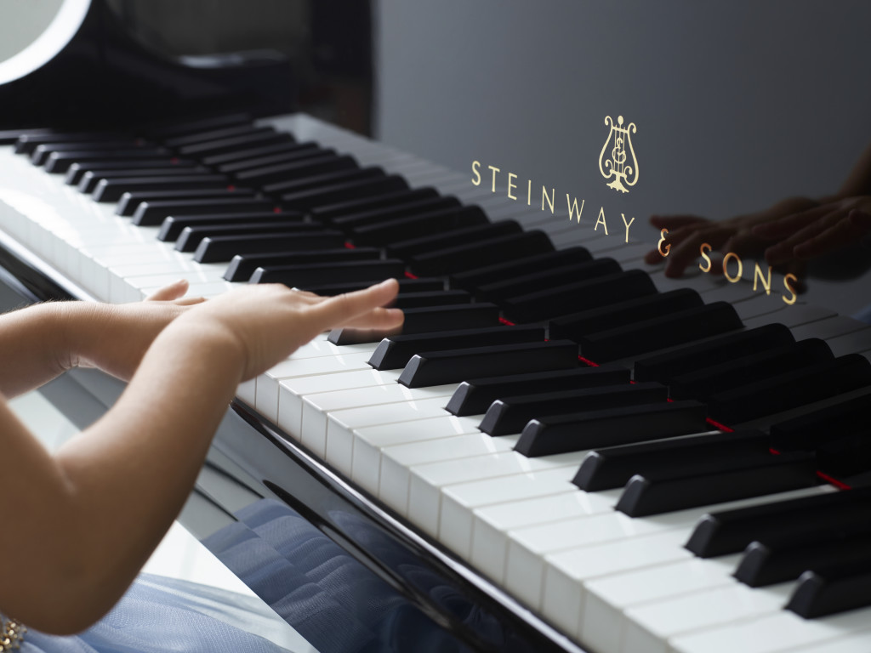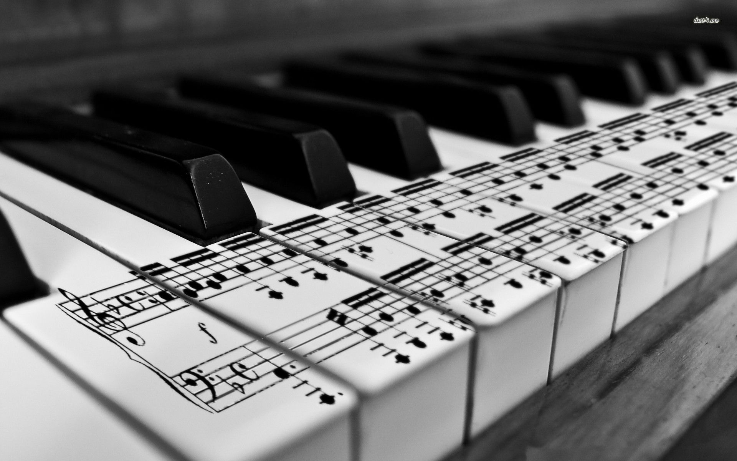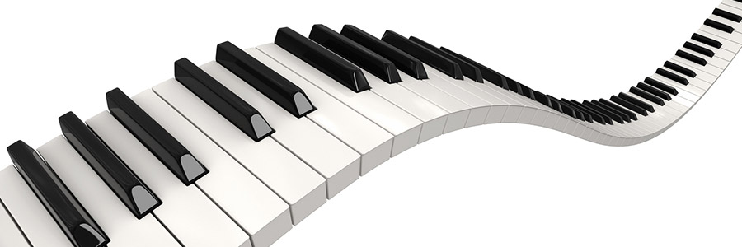

🙞 🙜

439 Lees Mill Road  
Fayetteville, GA 30214

404-808-8813

bynoe510@yahoo.com

allanbynoe.com

Allan Bynoe

**Individual Lesson Fees:**

(Charged per lesson for students beginning mid-month)

Private Lesson – 30 minutes $18.00

Private Lesson – 45 minutes $33.00

Private Lesson – 60 minutes $48.00

Monthly Tuition:

(After mid-month lessons, monthly tuition begins)

Private Lesson 30 Minutes $72

Private Lesson 45 Minutes $132

Private Lesson 60 Minutes $175

Bynoe’s Music School

## Rates and Fees

I do my best to provide knowledgeable instruction and guidance in all of these areas.

In summary, I offer piano instruction in a relaxed atmosphere, and in a way that is encouraging and rewarding to each individual student. I know that if you don’t like something, you will not want to spend a lot of time doing it. That is why it is so very crucial that my students enjoy their lessons and their practice time, even when it means having to put out a lot of effort. I may be their teacher – but I am also their biggest fan. I am always ready to give them heaps of praise for a job well done.

### Music Teachers National Association Inc. Georgia MTA

🙞 🙜

Osby Christian Academy

because it is laid out in the most logical manner, is easiest for a beginner to understand, and has a wealth of information (music theory) that is very useful, even after the student has progressed to higher levels.

For students in the intermediate levels, I offer counsel concerning what pieces they may enjoy playing, and work closely with them on more difficult supplemental exercises (when applicable). Some students really enjoy playing “classical” pieces, and others would rather learn to play show tunes and movie themes.

Some may want to learn how to play “jazzy” or “blues-y” music. Because my goal is to have happy, motivated students who LIKE to practice.

As a member of Georgia Music Teachers Association (GMTA) we are committed to furthering the art of music through programs that encourage and support teaching, performance, composition and scholarly research.

**What I Offer**

I specialize in teaching beginning to intermediate level piano, and give lessons to children as well as adults. Anyone who would like help building a strong musical foundation will find my instruction comfortable, enjoyable and worthwhile.

Although I do follow a certain curriculum for beginning students (John Thompson Level I) I am also very flexible in my approach, and assign supplemental (fun!) exercises to assist them in learning the physical skills that are needed to play the piano well. I have had experience with a number of beginner books and have purposefully chosen to use the John Thompson

# Piano lessons for all ages